**How to create New Instance from ISO and create a template. Ubuntu 18.04**

**Step 1:** Log in to the CloudStack UI as an administrator or user.



**Step 2:** In the left navigation bar, click Instances.

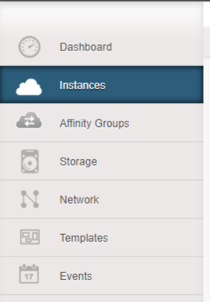

**Step 3:** Click Add Instance.

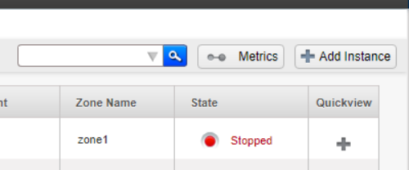

**Step 4:** Select a zone.

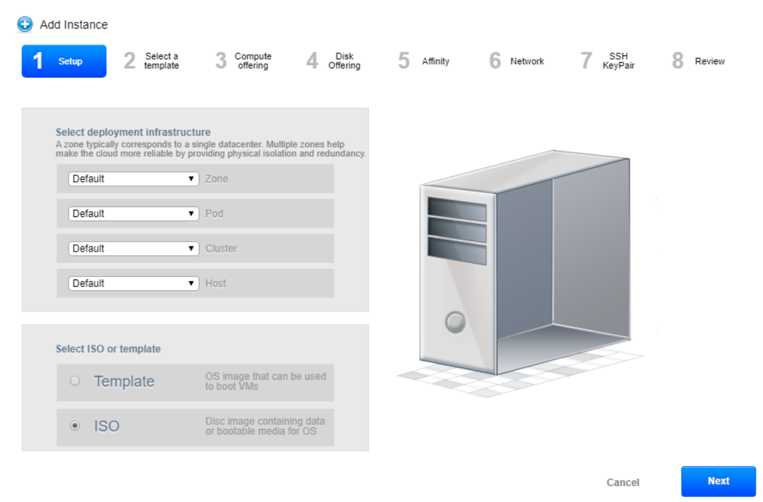

**Step 5:** Select ISO Boot, and follow the steps in the wizard.

There are a few options to choose from depending on what VM operating system is offered. In this document it`s used to create Ubuntu 18.04 ISO to work with.

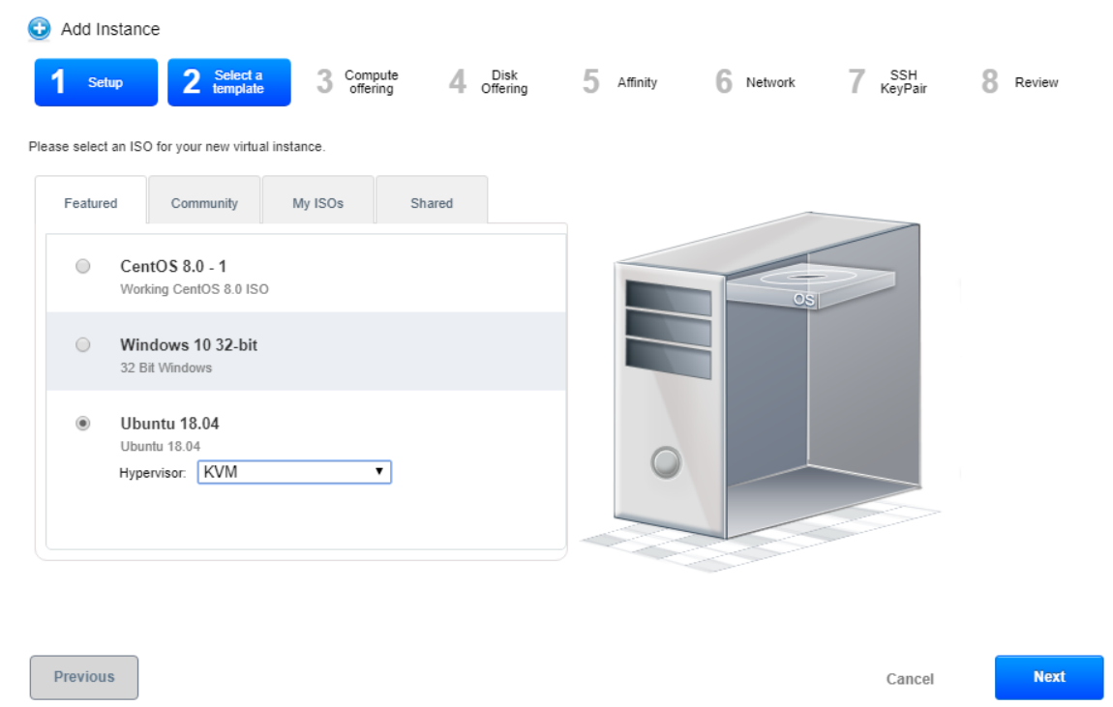

Next, choose specifications such as number of CPU cores, amount of GHz and RAM. Choosing X-large option contains 4CPU cores.

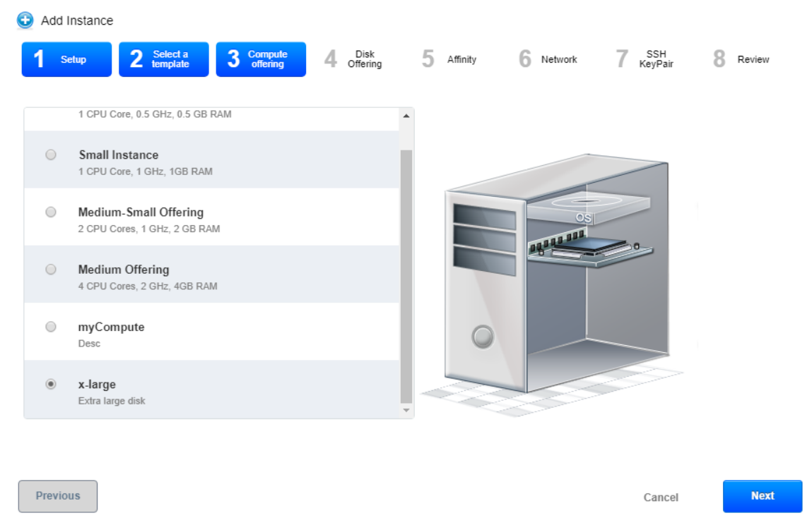

Disk Offering: It is possible to choose disk option as 5, 20 or 100 GB. For the purpose of the project, 40GB hard drive was manually chosen.

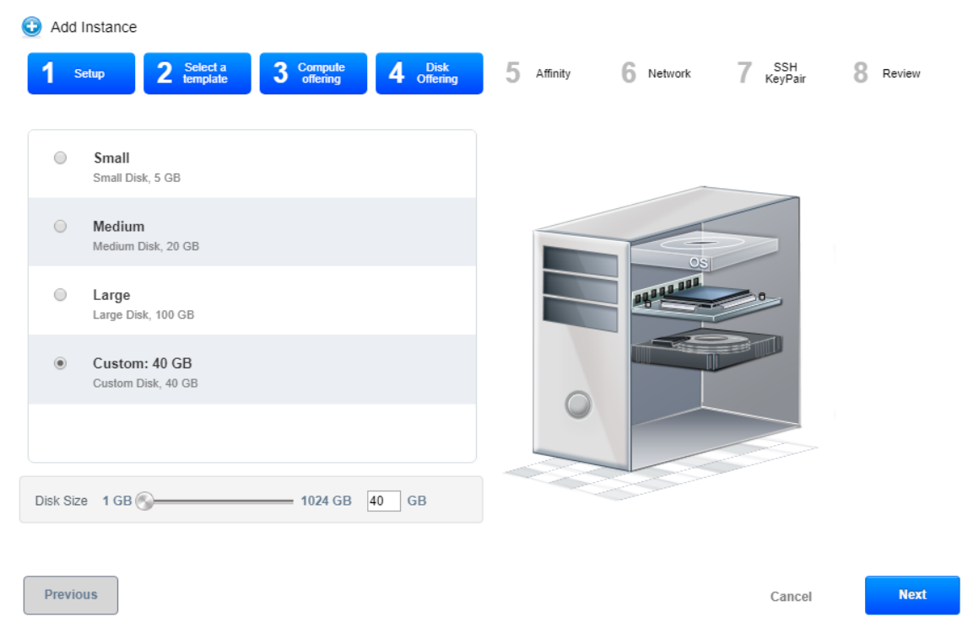

Click next for the rest of the steps and name your VM at the end.

**Step 6:** The installation of ISO starts:

In Quickview find View Console and click on it, it will open the VM.

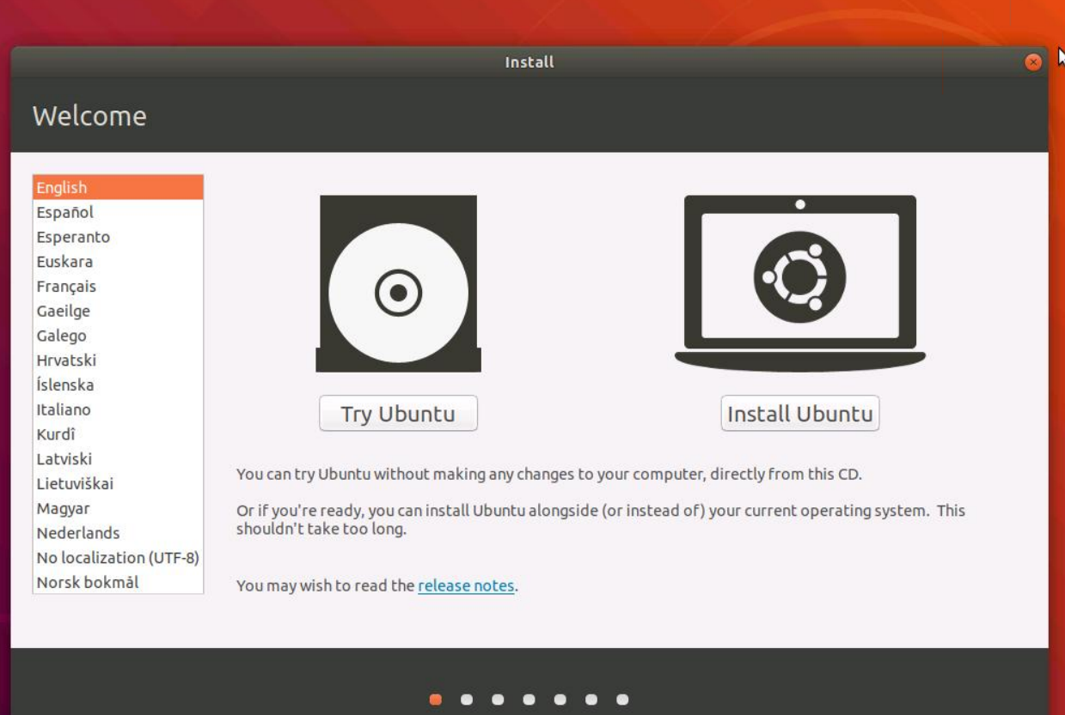

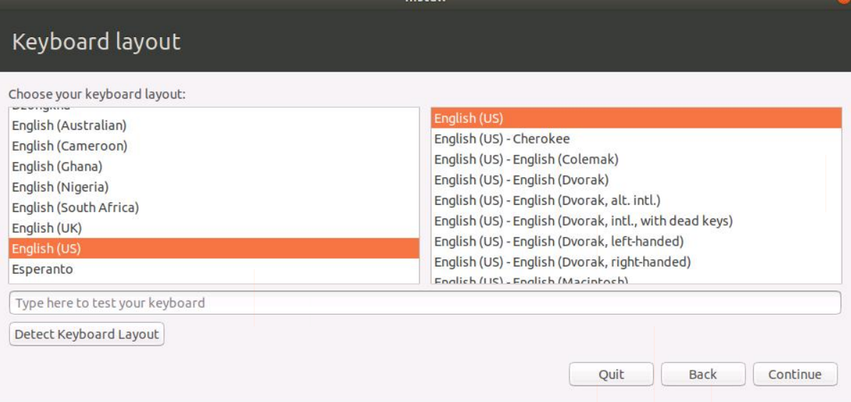

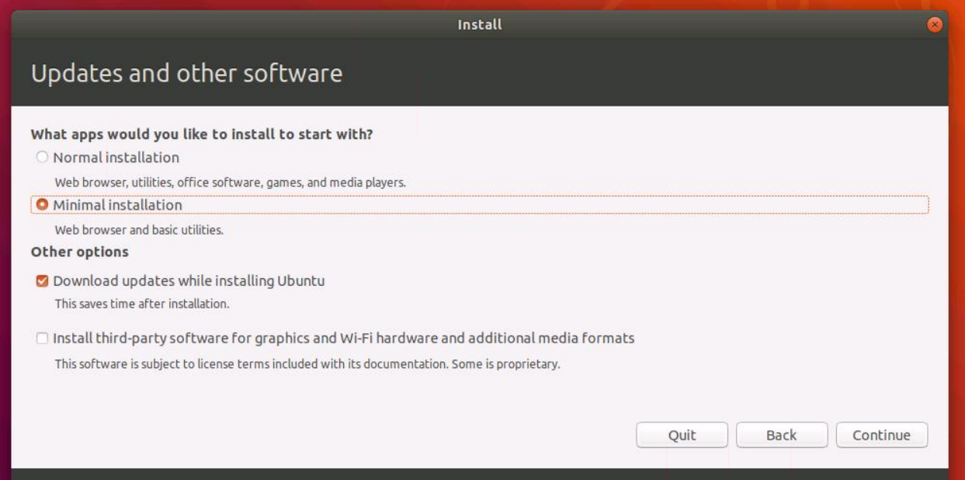

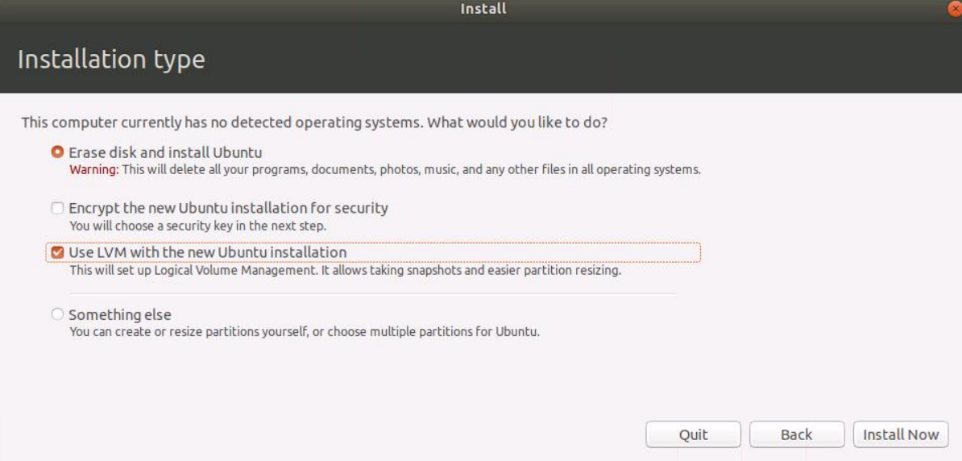

Choose something easy and simple for the name and password:

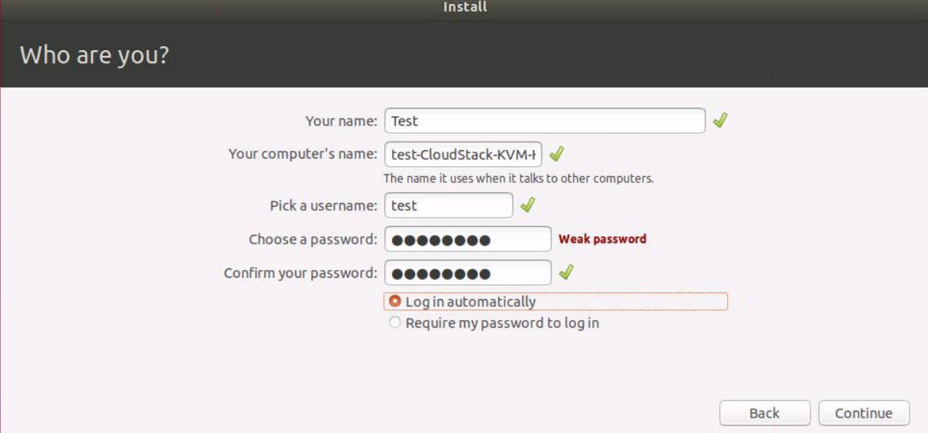

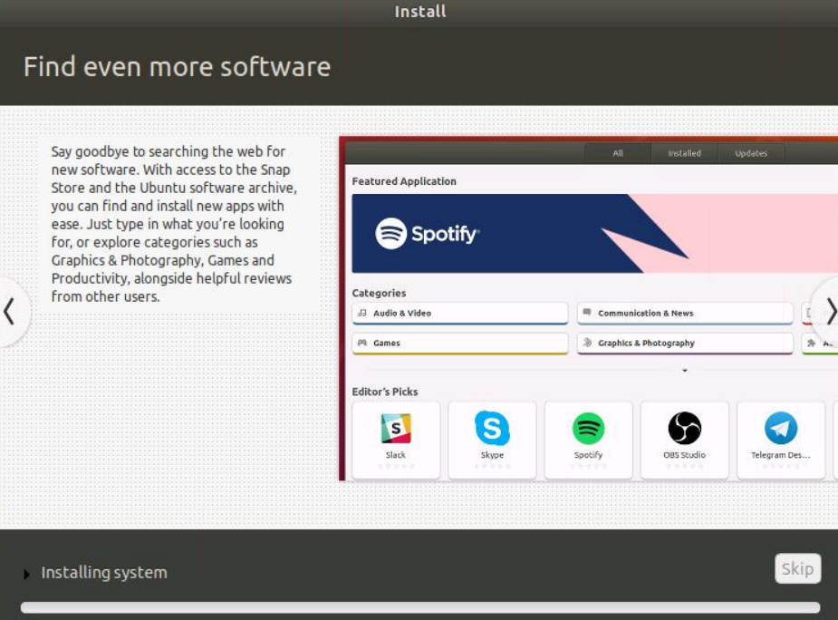

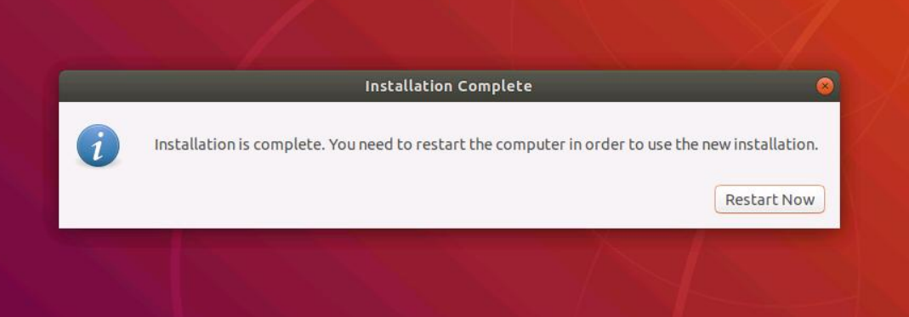

After restarting the VM, stop the instance in Quickview. Once the instance is stopped, proceed to the next steps to create the template.

Go into “View Volumes” and select the Volume having the type “ROOT”.

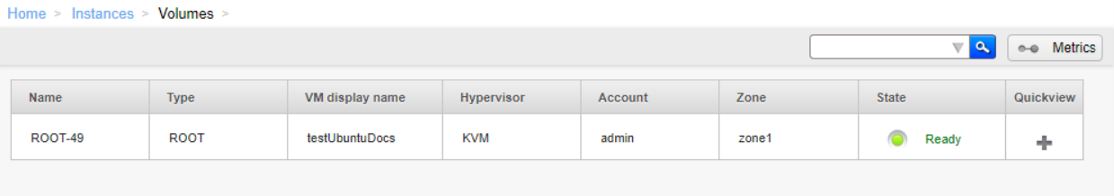

Click Create Template and provide the following:

Name and Description (choose something descriptive), OS Type (in my case it is Ubuntu 18.04 LTS), Public, Featured, Dynamically Scalable, then click OK.

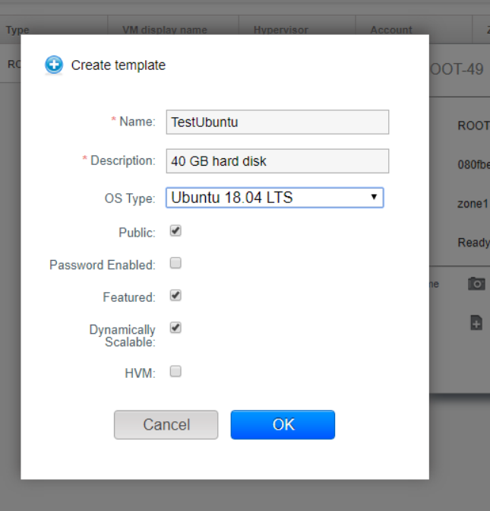

The new template will be visible in the Templates section when the template creation process has been completed. The template is then available when creating a new VM.

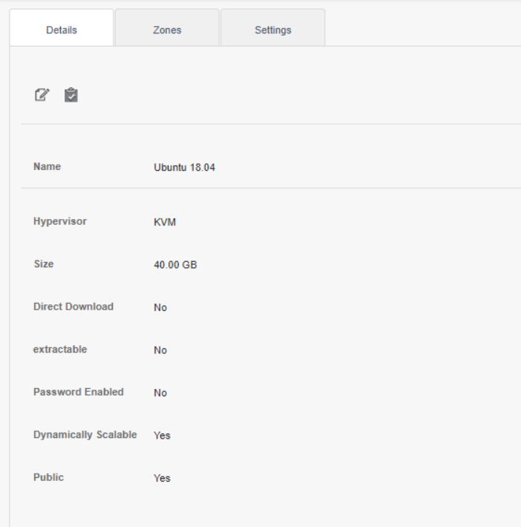

The Ubuntu 18.04 Virtual Machine from ISO and the Template were created. Now, start the instance and start using the VM by clicking view console.